|  |  |  |  |  |  |
| --- | --- | --- | --- | --- | --- |
| Date | 29-Nov-22 | | | Tester Name | Mayuri Patel |
| Environment | Penfax - Test | | | Login used |  |
| Operating System | Select OS | Version: | Update: | | |
| Software Used | Select Software | Version: | Update: | | |
| Select Software | Version: | Update: | | |
| Release version | 22.4.1 | | | | |
| Title |  | | | | |
| Test Type | Regression | | | | |
| Test Scenario | Process an interfund transfer the same day as the monthly payment run | | | | |
|  |  | | | | |
| Expected Results |  | | | | |
| Pass/Fail | Pass | | | JIRA# | N/A |

Describe your steps with screenshots:

Find a VPB active member who has current Scheduled withdrawal

Open that member Profile

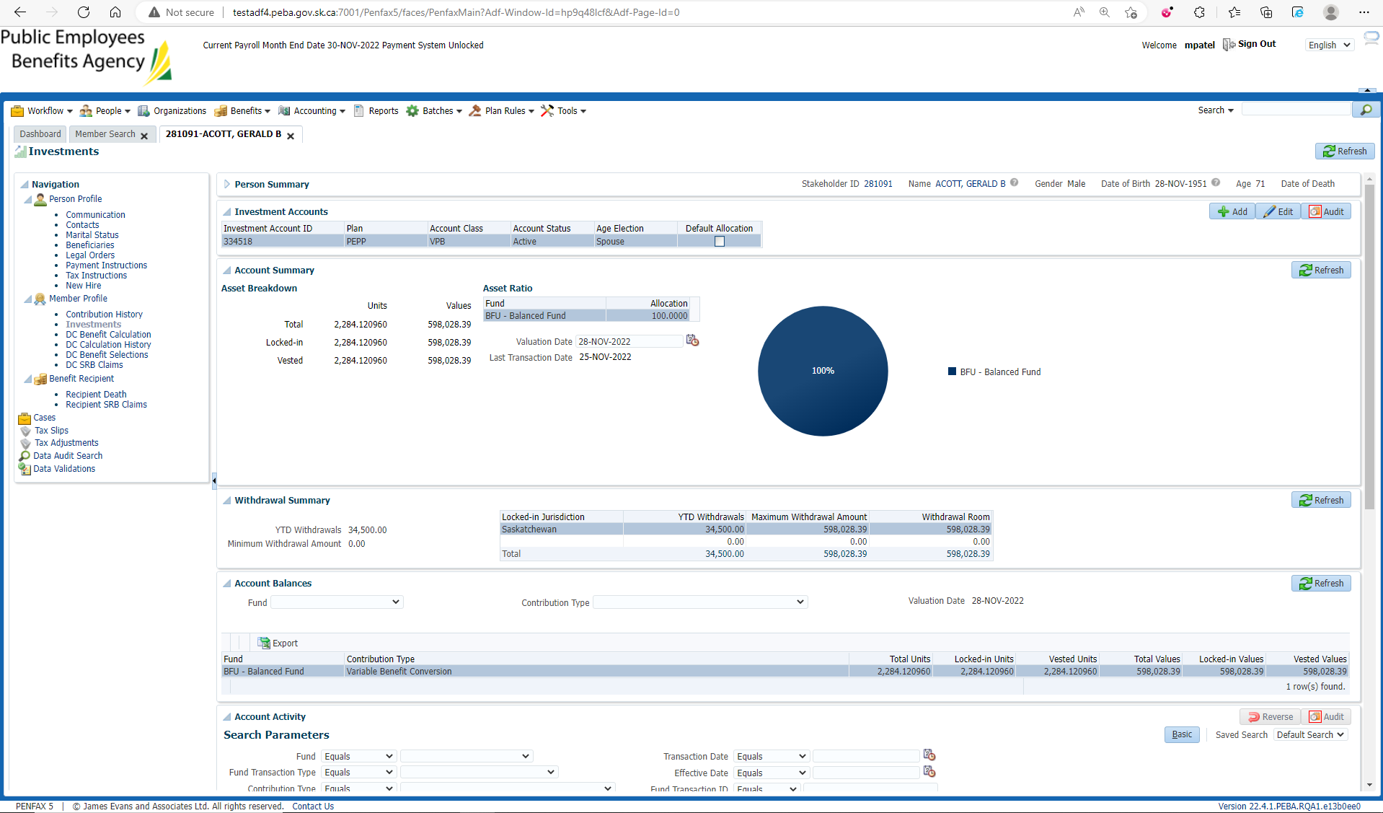

Current scheduled Withdrawal

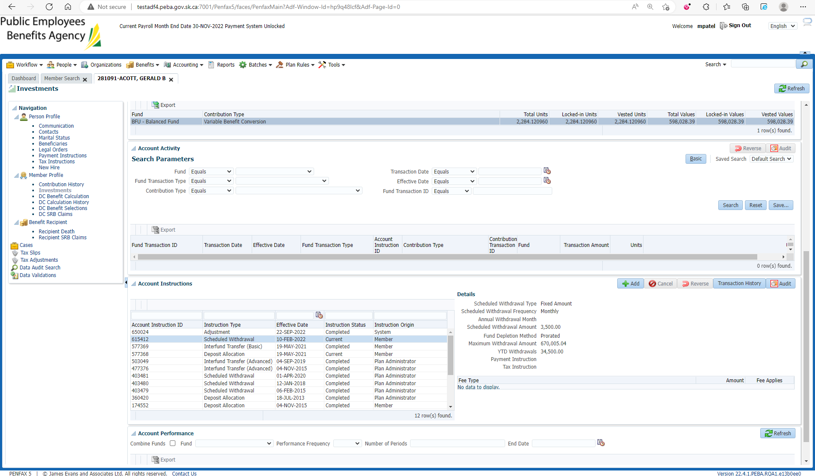

Open that member’s Pen web Account

My Investment

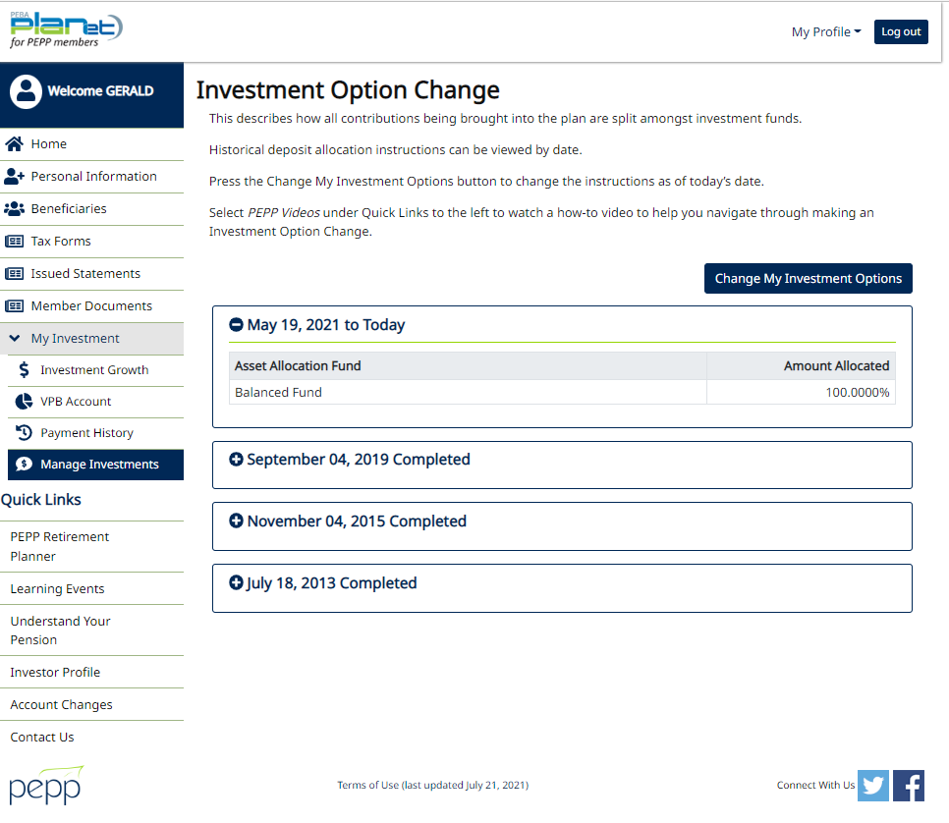

Change my Investment Options

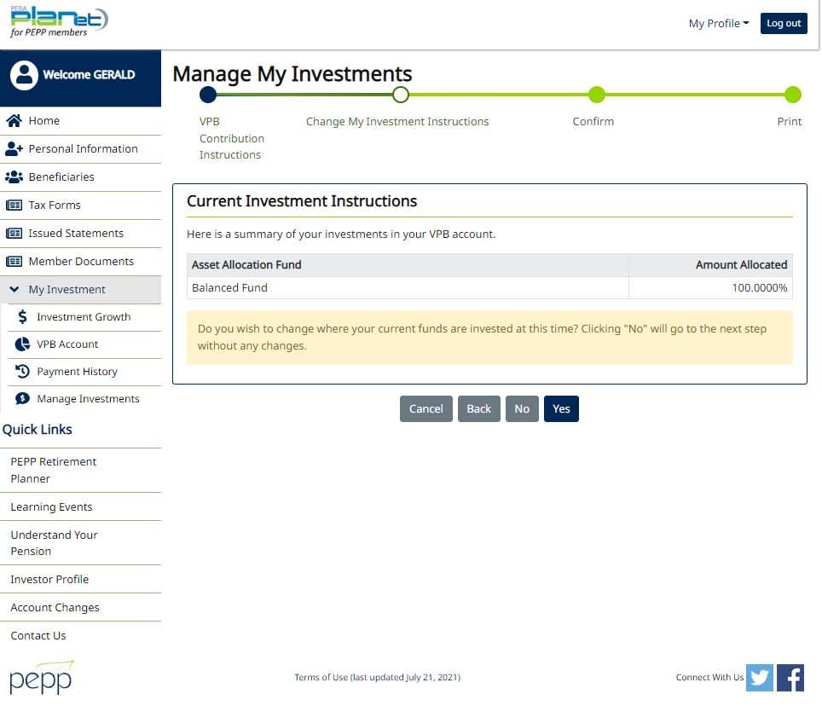

Add any Specialty fund for Inter fund transfer and Next

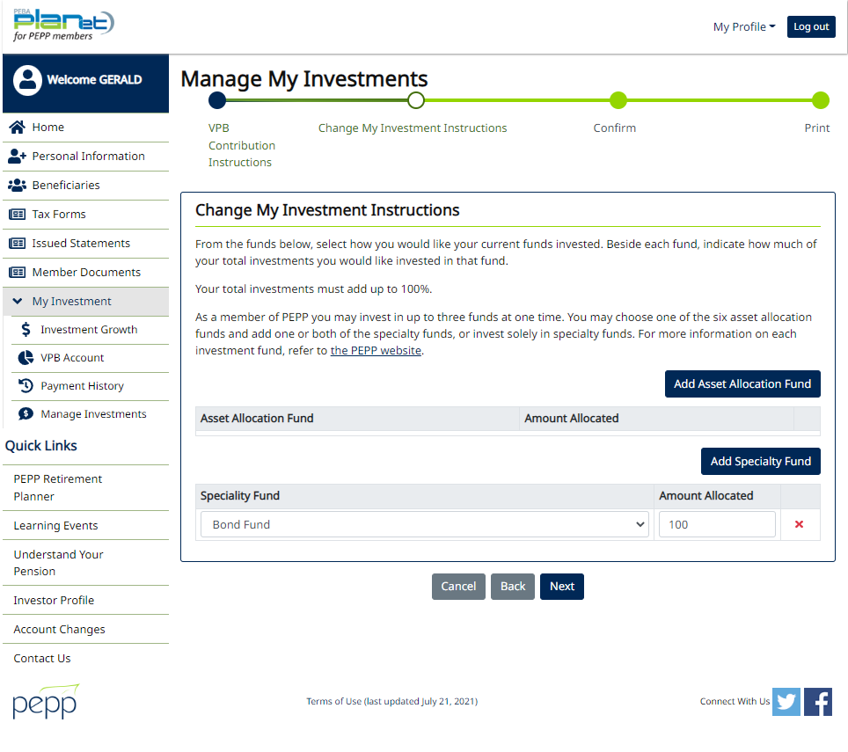

Confirm it

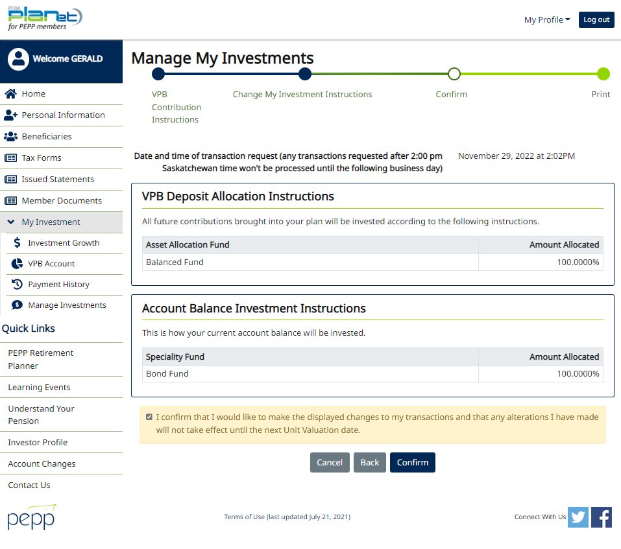

Validations are not thrown on Pen web while processing Interfund Transfer on the same day as monthly payment run

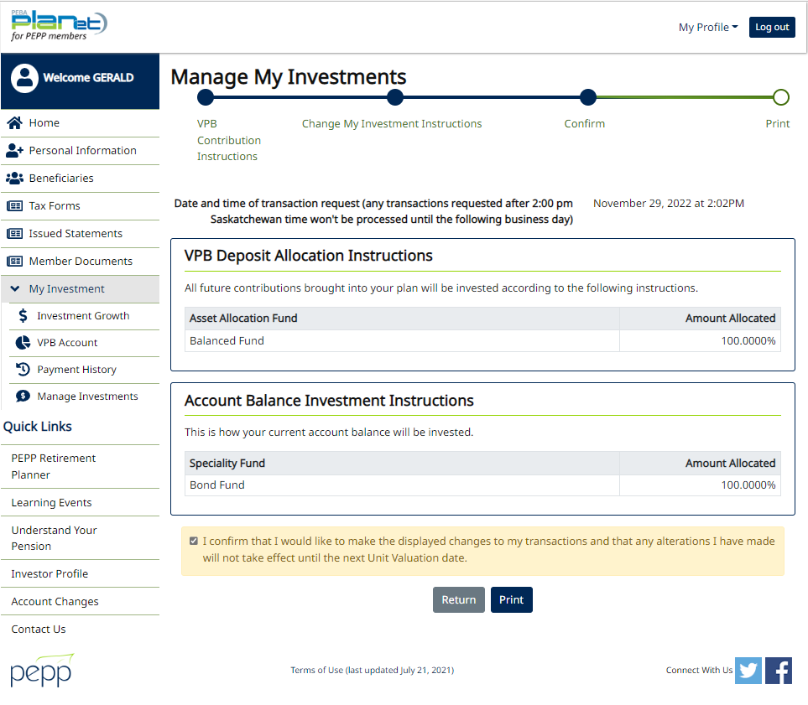

Same steps processed through penfax

